PART 3: DATA MODELLING

Introduction
Data modelling is the process of organizing data into related tables to improve data analysis. In this project, the model supports efficient filtering, DAX calculations, and interactive dashboard visualizations.

Fact Table
The ratings table was selected as the fact table because it stores transactional information. Each row represents a rating submitted by a user for a specific movie.
Key fields include:
- movieId
- userId
- rating
- timestamp

Dimension Tables
movies_metadata: Contains movie information including title, genres, runtime, language, popularity and release date.
credits- Contains cast and crew information.
keywords- Contains movie keywords used for categorization.
date- Custom calendar table used for time.
The links table was used as a bridge table because it connects TMDb movie identifiers with MovieLens identifiers, allowing the ratings table to relate correctly to movie_metadata.

Date Table creation
To support time-based analysis, a custom Date table was created using DAX.
The Date table was generated using the CALENDAR() function with the minimum and maximum movie release dates.
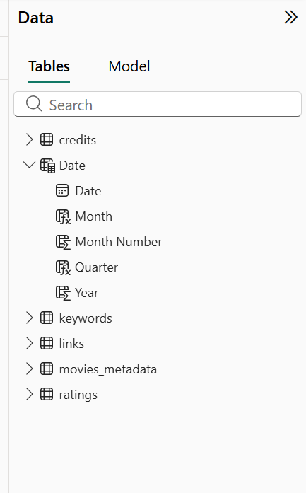
Additional columns such as Month, Month Number, Quarter and Year were added to the date table. Below is a screenshot of the DAX formulas to create those columns.

Relationship
The screenshot below shows the relationship between the Date table and movies_metadata table.
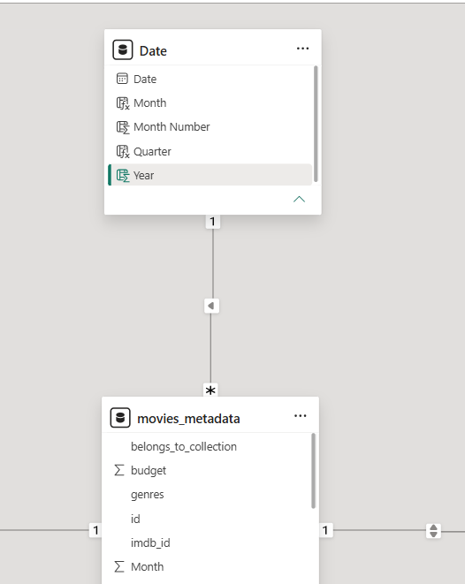
Below is a screenshot of the relationship between movies_metadata table and links table.
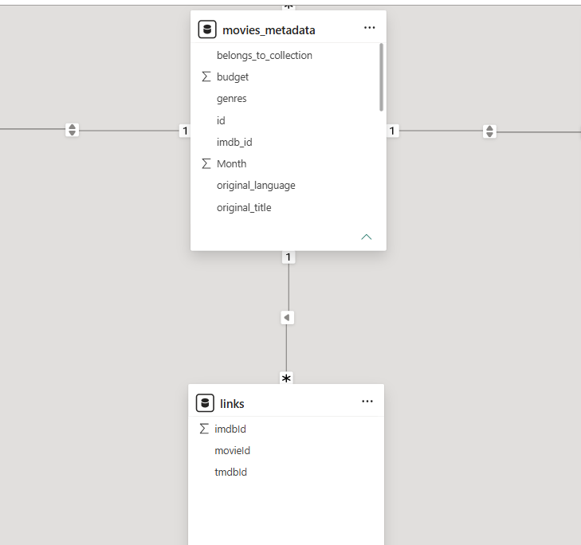
This next screenshot (below) shows the relationship between links table and ratings table.
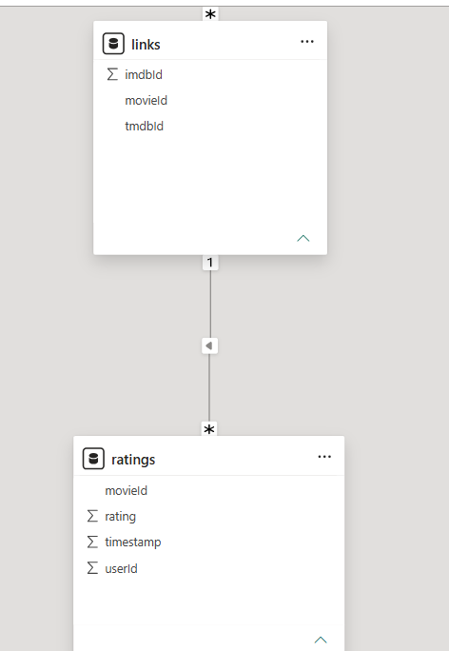
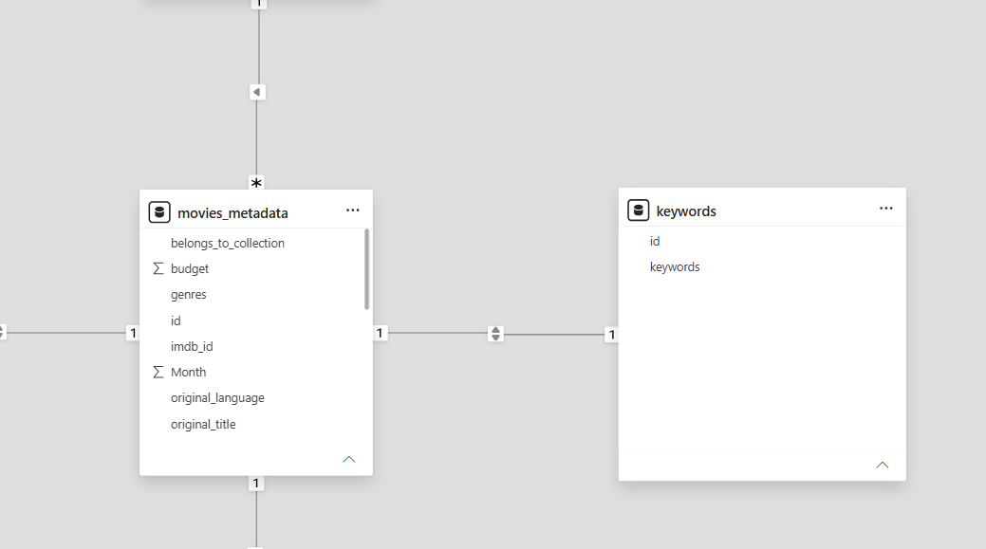
The above image shows the relationship between movies_metadata table and keywords table while the one below shows the relationship between credits table and movies_metadata table.
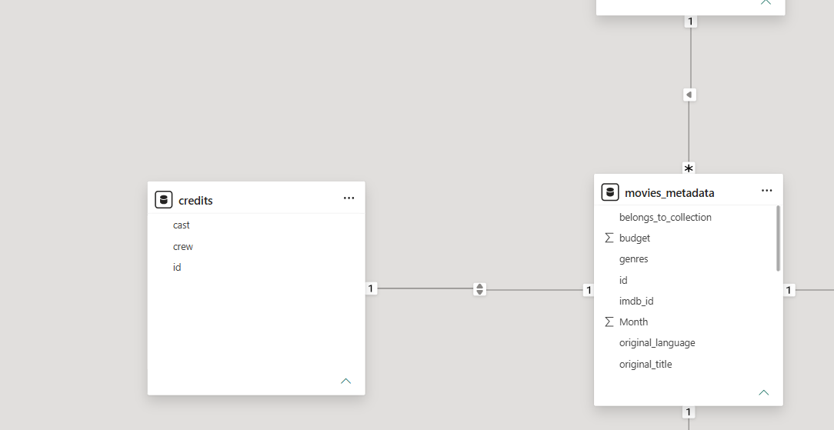
Relationship | Cardinality | Cross Filter
movies_metadata[id] → credits[id] | One-to-One | Both
movies_metadata[id] → keywords[id] | One-to-One | Both
movies_metadata[id] → links[tmdbId] | Many-to-One | Single
links[movieId] → ratings[movieId] | Many-to-One | Single
Date[Date] → movies_metadata[release_date] | One-to-Many | Single

Final Data Model
The final data model follows a star-like schema. The ratings table serves as the fact table, while the movies_metadata, credits, keywords and Date tables function as dimension tables. The links table acts as a bridge table connecting TMDb identifiers to MovieLens identifiers. This model provides efficient filtering, supports DAX calculations and improves dashboard performance.
Below is an image of the model view.

